GPEC 443 – GIS – McCord [SP19]

Final Project

Xinyu Huang

June 14, 2019

Did the Chinese Government’s Investments Go Along with Belt and Road Initiative in Its Primitive Stage?

1. Introduction

The Belt and Road Initiative (BRI) is a development strategy to build a trans-continental network of infrastructure consisted of megaprojects with a total value of $4-$8 trillion US dollars until 2049.[1] It is composed by the Silk Road Economic Belt and the New Maritime Silk Road. Until 2017, projects with a total value of $900 billion were marked as BRI-related, ranging from “roads, pipelines, and utility grids”.[2] It is no surprise that such a gigantic initiative was not built in one day. It was firstly introduced by Chinese President Xi Jinping on September 2013 in his speech delivered at Nazarbayev University during his visit to Kazakhstan.[3] Then on March 2015, its action plan was firstly released, accompanied by its principles, framework, and priorities related to enhancing regional connectivity.

This article traces geo-located projects funded by Chinese government back to the primitive stage of the BRI around 2013. It mainly answers the question: is there any change in the pattern of Chinese government-financed projects in 2014, when the BRI launched? This article starts with a brief literature review on studies about this subject and then finds that there is no article studying the path dependency of Chinese overseas investments particularly around 2013, which is the primitive stage of the BRI. The article then lists data sources and gives overviews of them. By using the dataset “Global Chinese Official Finance” from AIDDATA, I propose two hypotheses examining the existence of preferences on investing in countries along BRI and the treatment effect of BRI in 2014. Regression models indicate that BRI countries were equally favored in terms of investment in history and there is no significant increase in their investment numbers in 2014. Empowered by maps of kernel density, hot spots, and GWR made by ArcGIS, this article then identifies specific projects, locations, and countries that actually demonstrate changes of investment pattern around 2013, undetected with statistic models. It concludes that even though there is no significant alteration of preferences of Chinese investments in general, subtler changes happen at lower levels. The BRI was proposed in the way that it included most of the countries benefited greatly in the past from China’s finance. It also indicates that the BRI comprises other countries with weaker connections for other reasons, for instance, to extract more exports in the future.

2. Literature Review

As summarized by the World Bank, the meaning of BRI lies in its power to “transform the economic environment in which economies in the region operate.”[4] Many articles focus on the economic opportunities that the BRI brings to its participants and regions along the Road.[5] If we further break down the most tangible part of BRI, we could find the network of infrastructures supported by all kinds of Chinese stakeholders: state-owned companies, government, private firms. The role of the Chinese government here is the same: to promote local economic development. In a more tangible way, it is to improve the infrastructure of the target country in forms of the Official Development Aid (ODA), Other Official Flows (OOF).[6] It is possible that Chinese government is incentivized to expand its foreign aid supply as a “valuable stimulus for exports”.[7] Increasing trade thus coincides with the slogans of the BRI: connectivity and regional cooperation.

As the concept of BRI became more and more “heated”, it is reasonable that China has its resolve to promote its cooperation with countries along the BRI and benefit from the more developed infrastructure. In doing so, China might focus on its good neighbors with a long history as trade partners. However, Chinese government might also take advantage of the BRI and build new connections with countries along the road, from which China hopes to export new goods to stimulate its economy. Hypothesis 1 of this article is, therefore: OBOR countries are more favored by Chinese investments historically.

Another interesting topic this article explores is the process of China developing its global strategy BRI. Despite the enormous number of the total value of projects accumulated until now, we may wonder if the BRI is a sophisticated project that China has planned and prepared for a long time or China was just “crossing a river by feeling his way over the stones”, which means other countries joined the Initiative gradually and got increasing official investments after several years. Therefore, hypothesis 2 that the article proposes is: OBOR countries receive more investments since the initiative was proposed.

3. Data Sources:

This article mainly uses the “geolocated Chinese Government-financed projects that were implemented between 2000-2014”.[8] It has 3,485 projects with 6190 observations and $273.6 billion in the total worth of official financing.[9] Among them, 3485 were geo-located. Though each observation has its source correctly recorded, only 1817 of them have a traceable number of total expenditures.

Figure 1 describes the total sum of reported currency of government-financed projects deflated to 2014 USD dollars by year. Despite fluctuations, we may observe an upward trend of overseas investments. In the analysis below, since the BRI was firstly announced in 2013, 2014 is taken as the first year after treatment.

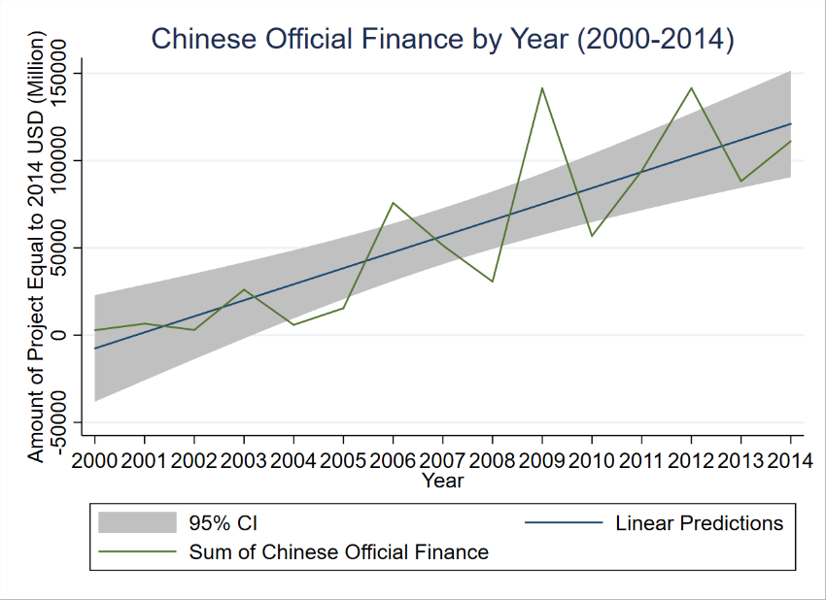For panel analysis, this is a heavily-unbalanced data if summed by country. There are 67 unique countries that have records in 2012 & 2014, 53 in 2012, 2013, 2014, only 47 in 2011, 2012, 2013, 2014.

*Fig1. Trend of Chinese finance overseas*

To visualize the distribution of the projects near the BRI, figure 2 projects them by the size of expenditures on the map with a projection of WGS 1984. The size of dots is categorized by numbers close to geometrical intervals. We can see from the map that the majority of projects are with little and missing values. Iran, Turkmenistan, Uzbekistan (which are alongside the New Eurasia Land Bridge Economic Corridor), Ethiopia, and Kenya are the countries that 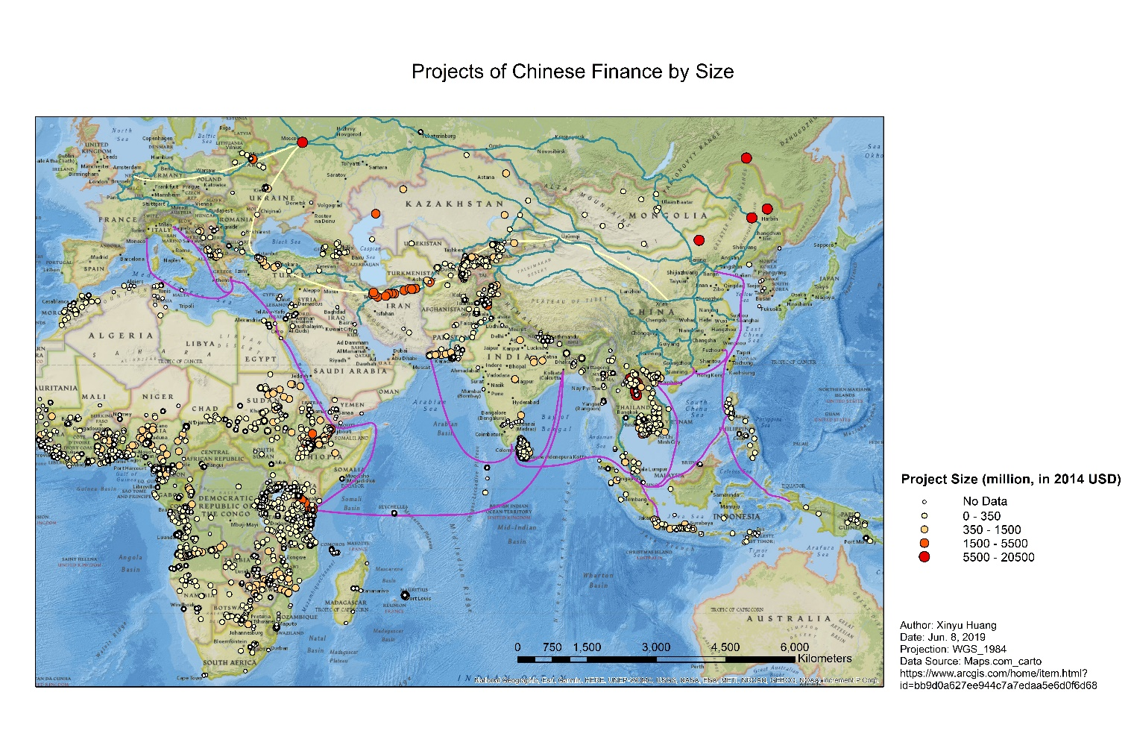have attracted remarkably large projects from China.

*Fig2. Projection of projects across 2000 – 2014 worldwide*

*Fig3. Pie charts of size of expenditures (2000 - 2014)*

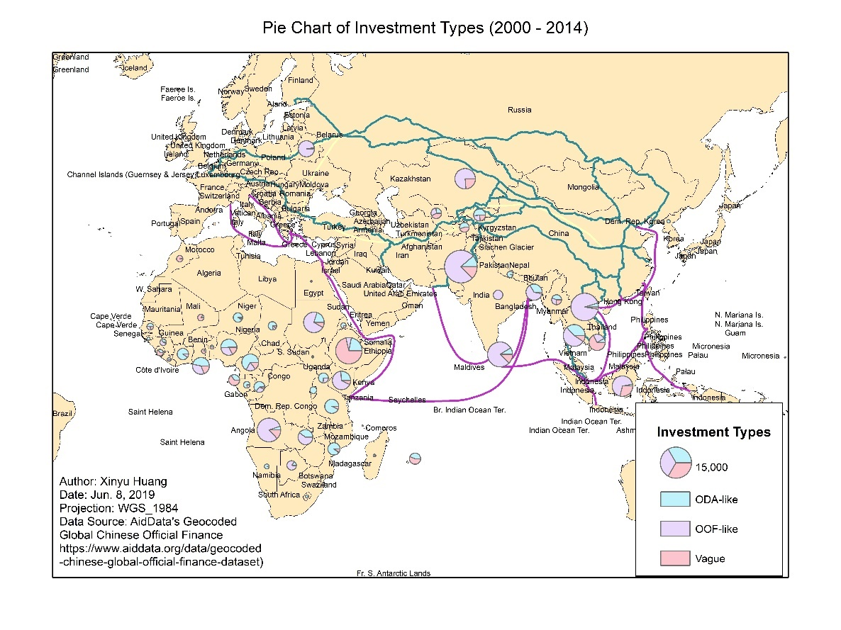Figure 3 sum them by countries and then breaks down by category of investment: ODA, OOF, and vague. [10] This map demonstrates a quite different pattern of investments. It is not countries in central Asia that attracted most investments over the years, but those in South-East Asia and in Africa. It is Pakistan which receives most support ($16.40 billion) from Chinese government among all. The shapefile of the Belt and Road is made by “Maps.com_carto”. It also includes all economic corridors that reach out to many participant countries along the Road. The geographical background with the basic 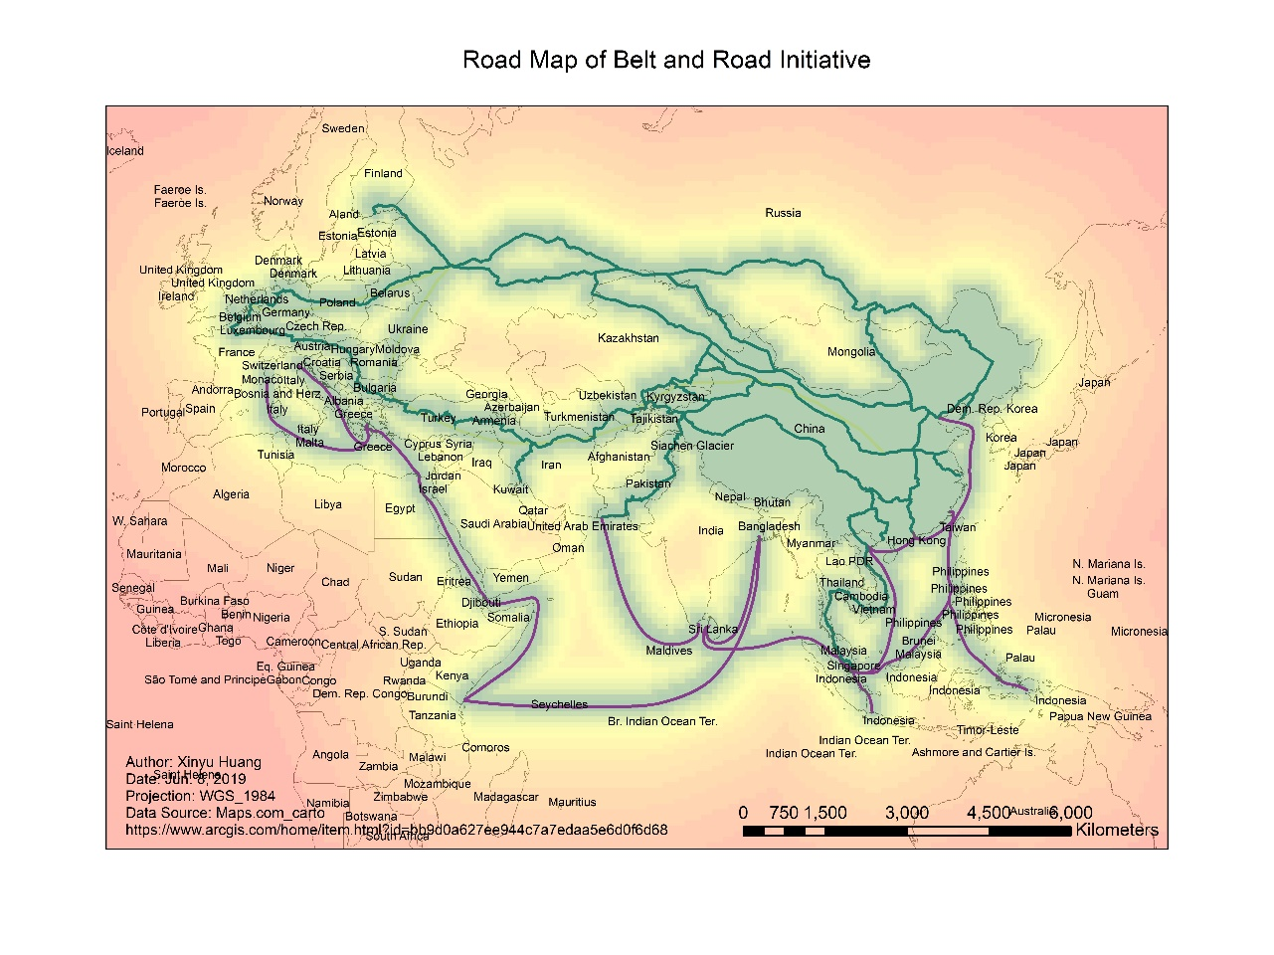landscape is from Esri for educational and informational purposes.[11]

Another important source of information is the list of countries along the Belt and Road (in Chinese “一带一路沿线国家”). It is hard to find an exact list because the official list records countries that have signed cooperation documents until today[12] but not those geographically close to such lines. In order to draw conclusions about how the BRI affected countries along with them in its first stage, the list is chosen from earlier reports, which all originally cited from Xinhua Net.[13]

*Fig4. The Belt and Road and where is near?*

Control variables including population, GDP per capita, imports of goods and services (% of GDP), and exports of goods and services (% of GDP) of each country in years 2010 – 2014 are from the World Bank Open Data.

4. Methods

To test whether OBOR countries are more favored by Chinese investments historically, this article runs detrended pooled-OLS with and without control variables, clustered by countries and with country dummies. The time range is from 2010 to 2014.

where the observations are countries. The total value of projects in a country in one specific year and number of projects are adopted as dependent variable. OBOR is a dummy variable indicating whether the country is along the Belt and Road.

After the regressions, hotspot maps, both weighted and unweighted are drawn to identify which BRI country was more favored than others on the map. In ArcGIS, we need first to display dots of projects from 2010 to 2014 by their coordinates on the GCS_WGS_1984 geographic coordinate system. Then it is needed to export it as a shapefile to create a unique object id. Then the tool Optimized Hot Spot Analysis is used twice to create hotspot maps unweighted and weighted by average project value per dot. Such maps distinguish regions which 1) has a spatial correlation of values with regions nearby, 2) has a significantly higher or lower value. For the weighted map, geoprocessing tool Buffer is used to create buffers that make significant spots more salient by choosing spots whose G-Bin is equal to or greater than 2 (95% CI). The dissolve type of Buffer is ALL so that boundaries of buffers automatically overlap. The linear unit is chosen as 200 km to be visible on the map. For the unweighted map, the method Optimized Hot Spot Analysis can be used to create a fishnet with “COUNT_INCIDENTS_WITHIN_FISHNET_POLYGONS” and the color of the fish map can tell the results directly.

To test whether BRI countries receive more official support since the initiative was proposed in 2013, I use the two-period difference-in-difference models with and without control variables while assuming there is a parallel trend among BRI countries and non-BRI countries. These two periods are 2012 and 2014. Their function expressions are shown below:

O

O,

where variables have the same meaning as above. The coefficient is the effect of treatment, which reflects how much more or less overseas aids a BRI country receives from China in 2014 comparing to the number it would receive if it’s not in the list of BRI countries. Two periods are chosen to keep the number of countries as more as possible because of the high unbalanced nature of dthe ataset.

Kernel density maps are created to further identify how the density of projects changed in 2012 and 2014. The tool Kernel Density from ArcGIS is then used to calculate in which region there has a larger number of projects. They are unweighted by the average value of project since the distribution of economic values are right-skewed and density map would be heavily influenced by them. Instead, all projects are just marked by size on the map. In the end, the Geographically Weighted Regression (GWR) is used as a local form of linear regression to evaluate the spatially varying coefficient of . The GWR model considers the first difference of the total value of projects within a country as dependent variable, and is independent variable. Control variables are not added into the equation because of their little influence in previous FE models.

5. Results

|  |  |  |  |  |  |  |
| --- | --- | --- | --- | --- | --- | --- |
| Table 1. Pooled-OLS testing whether BRI countries receive more during 2010 - 2014 | | | | | | |
|  | (1) | (2) | (3) | (4) | (5) | (6) |
| VARIABLES | Project Values | Project Values | Project Values | Project Numbers | Project Numbers | Project Numbers |
|  |  |  |  |  |  |  |
| OBOR | 207.9 | 210.9 | -409.1 | 0.375 | 0.646 | -5.331*** |
|  | (134.7) | (150.2) | (514.7) | (0.598) | (0.645) | (1.843) |
| Constant | 162.5* | 484.7*** | 236.9 | 2.923*** | 3.430*** | 9.249*** |
|  | (93.51) | (163.3) | (546.7) | (0.350) | (0.668) | (1.803) |
| Clustered | YES | YES | NO | YES | YES | NO |
| Country dummies | NO | NO | YES | NO | NO | YES |
| Robust | YES | YES | YES | YES | YES | YES |
| Control Variables | NO | YES | YES | NO | YES | YES |
| Observations | 440 | 407 | 407 | 440 | 407 | 407 |
| R-squared | 0.018 | 0.045 | 0.410 | 0.007 | 0.060 | 0.551 |

Robust standard errors in parentheses

*** p<0.01, ** p<0.05, * p<0.1

Table 1 shows the results of pooled-OLS to examine whether BRI countries received more funds historically. Model 1-5 yields no significant coefficient while model 6 indicates that a BRI country has on average 5.33 projects less than non-BRI country after adding country dummies and other control variables. In general, there is not enough evidence to prove hypothesis 1, which indicates BRI countries were treated differently from other recipients of aids from China. The BRI was drawn in a way that it didn’t specifically list all great beneficiaries of Chinese official finance.

*Figure 5. Hot spots of official investments from 2010 – 2014 with 200 km buffer (Weighted) &*

*Figure 6. Hot spots in fishnet from 2010 – 2014 (unweighted)*

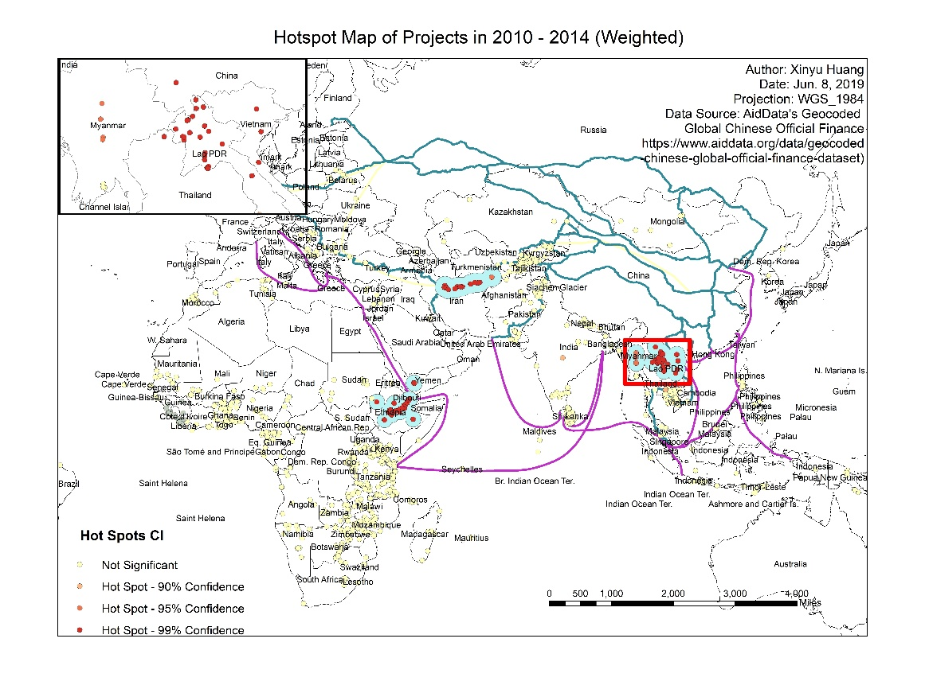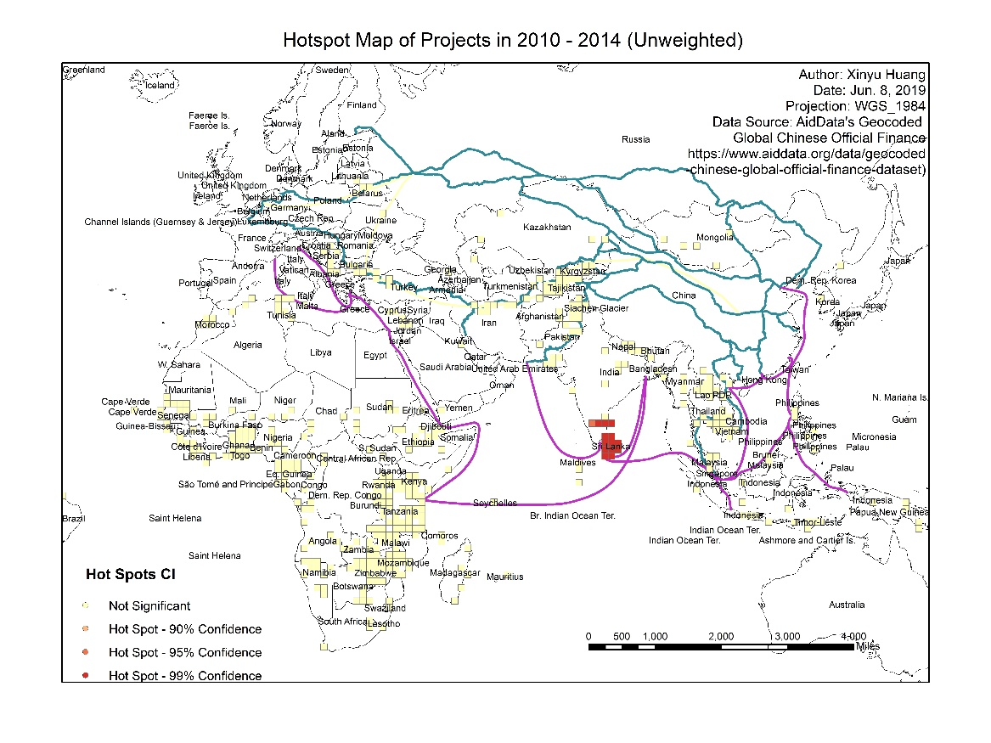There are three identifiable regions with significantly larger projects scale on the map. One cluster of hot spots situated in Laos. There were a 7600 million USD bank loans for construction of Kunming-Vietnam high-speed railway in 2012 besides other construction loans for power stations and a conference center. China also provided many medical supports to control diseases including free medical consultation in 2012 and other efforts to contain transboundary animal diseases. In Iran, CMC and SUPERPOWER’s agreement on the railway electrification program in 2014 contributes a cluster of hot spots, with a total value of 2.1 billion USD.

The map marked the railway route across Iran. Ethiopia mainly benefited from China’s assistance to the railway and light rail line projects, for instance, Addis Abada-Djibouti Railway in 2011 and Rail Line from Sebeta to Adama implemented in 2013.

Surprisingly, these regions are all in countries along the BRI road. Therefore, it is more likely that the BRI was firstly drawn in the way which large recipients were included but other countries with little finance before, with whom China might want to develop trade, were also absolved into this huge Initiative.

The unweighted map of hotspots shows that Sri Lanka has a significantly higher number of projects funded by Chinese government. Since Sri Lanka is also along the Maritime Road, the map further proves the argument that the Belt and Road include former large beneficiaries together with other countries.

More specifically, in Sri Lanka, China loans 259.78 million USD to finance its four road projects (No.45520), 102.7m USD loan to purchase Chinese power trains, funds for Priority Roads Project, construction of multiple highways, and a 138 million USD bank loan.

Table 2 shows the results of various difference-in-difference models. The treatment effect of BRI “1.OBOR#2014.year” is not significant in any case, which means a BRI country received no more funds from China in 2014 compared to the number it would have without being in the list. Therefore, current evidence is insufficient to prove hypothesis 2.

|  |  |  |  |  |  |  |  |  |
| --- | --- | --- | --- | --- | --- | --- | --- | --- |
| Table 2. Two-Periods Difference-in-Difference of BRI Treatment Effect (2012 and 2014) | | | | | | | | |
|  | (1) | (2) | (3) | (4) | (5) | (6) | (7) | (8) |
| VARIABLES | Project Values | Project Values | Project Values | Project Values | Project Numbers | Project Numbers | Project Numbers | Project Numbers |
|  |  |  |  |  |  |  |  |  |
| 1.OBOR | 437.0 | -977.9* |  |  | -0.0695 | -8.002*** |  |  |
|  | (308.4) | (537.4) |  |  | (0.590) | (2.344) |  |  |
| 2014.year | 21.10 | -70.91 | -32.75 | -70.91 | 0.463 | 0.551 | 0.500 | 0.551 |
|  | (82.99) | (171.4) | (88.66) | (103.6) | (0.404) | (0.867) | (0.457) | (0.524) |
| 1.OBOR#2014.year | -31.74 | -482.8 | -449.4 | -482.8 | -0.231 | -0.963 | -0.676 | -0.963 |
|  | (484.0) | (905.3) | (492.5) | (546.8) | (0.837) | (2.142) | (1.137) | (1.294) |
| Constant | 153.0*** | 844.2 | 362.6*** | 238.7 | 2.656*** | 7.243* | 2.675*** | -4.285 |
|  | (47.38) | (630.5) | (69.43) | (811.2) | (0.256) | (3.989) | (0.207) | (4.833) |
|  |  |  |  |  |  |  |  |  |
| Clustered | YES | YES | NO | NO | YES | YES | NO | NO |
|  |  |  |  |  |  |  |  |  |
| POLS | YES | YES | NO | NO | YES | YES | NO | NO |
|  |  |  |  |  |  |  |  |  |
| Fixed Effects | NO | NO | YES | YES | NO | NO | YES | YES |
|  |  |  |  |  |  |  |  |  |
| Country Dummies | NO | YES | NO | NO | NO | YES | NO | NO |
|  |  |  |  |  |  |  |  |  |
| Control Variables | NO | YES | NO | YES | NO | YES | NO | YES |
|  |  |  |  |  |  |  |  |  |
| Observations | 171 | 155 | 171 | 155 | 171 | 155 | 171 | 155 |
| R-squared | 0.037 | 0.750 | 0.045 | 0.053 | 0.007 | 0.653 | 0.016 | 0.045 |
| Number of countries |  |  | 104 | 95 |  |  | 104 | 95 |

Robust standard errors in parentheses

*** p<0.01, ** p<0.05, * p<0.1

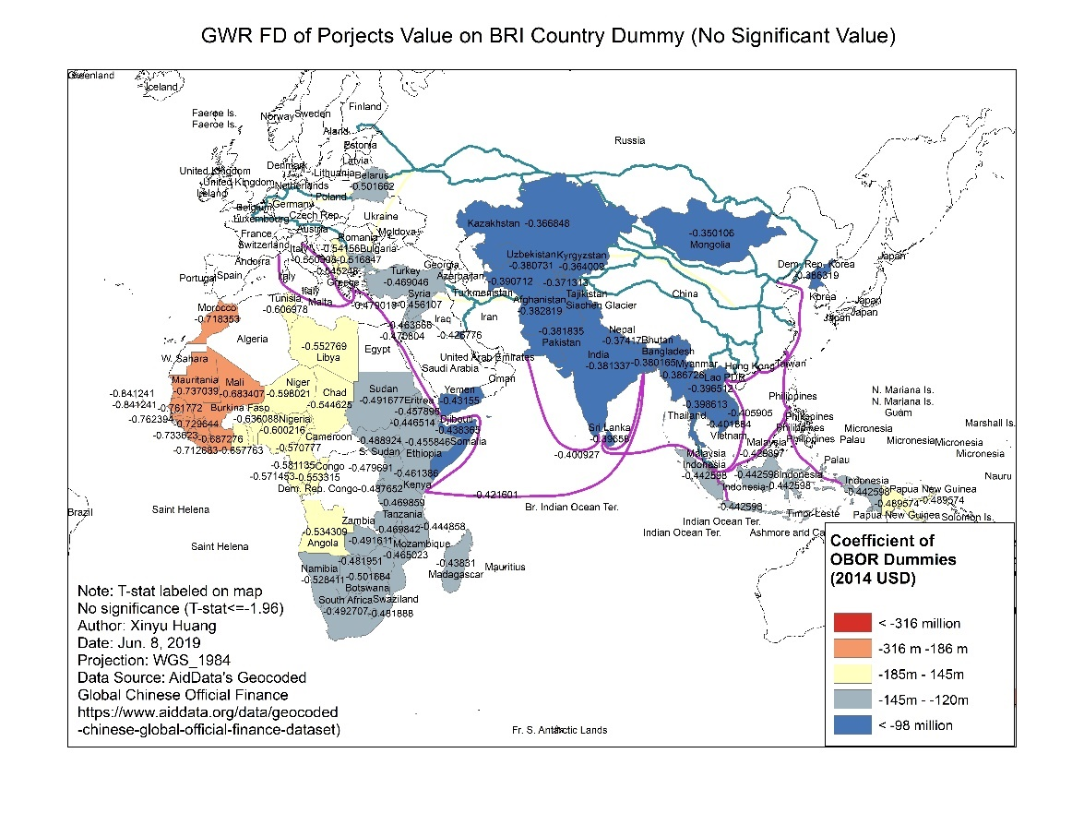*Figure 7. First difference of projects value on BRI country dummy (No significant Value)*

Given no significant estimates of treatment effect, we could still try to estimate these values on a country level supposing values of projects by country has a spatially varying relationship with the dummy variable. Figure 8 shows the variation of coefficients of BRI treatment effect by country. Although the coefficients vary between -316 million and -96 million, which means BRI countries around the region had less investments comparing to non-BRIs, none of these results are significant on 95% CI.

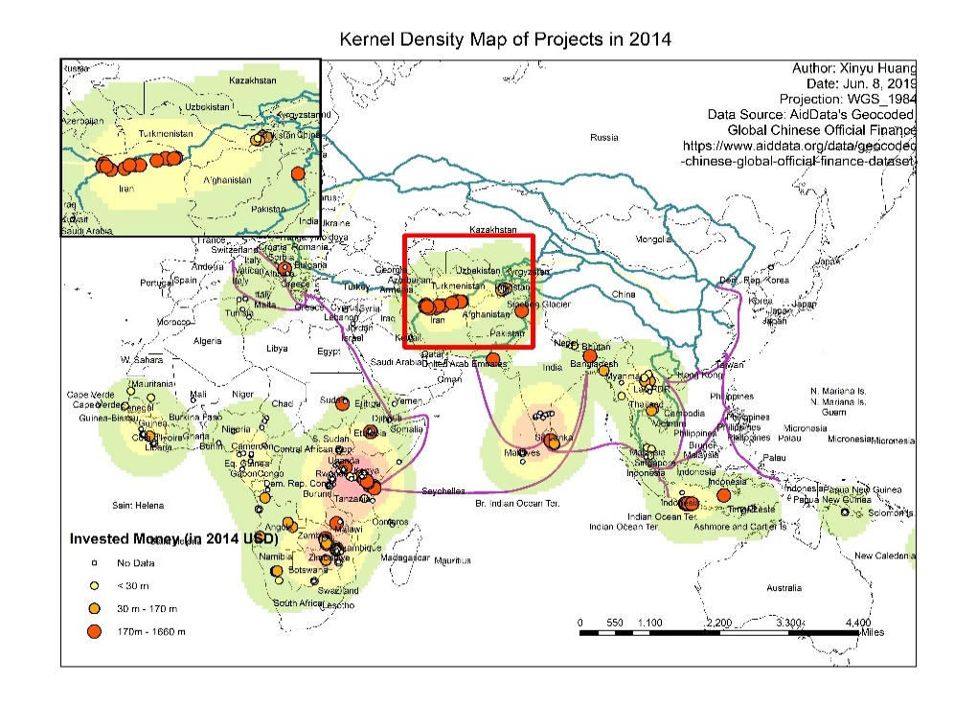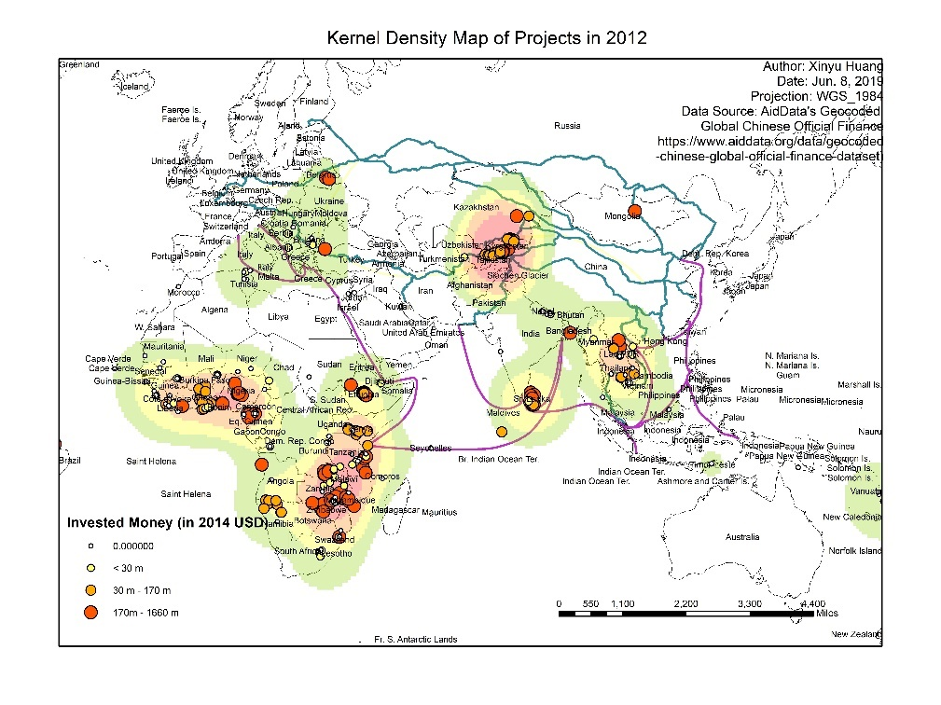*Figure 8. Kernel Density Maps in 2012 and 2014*

Figure 8 simply shows kernel density plots of projects in the pre-treatment and post-treatment era. Areas with high density still largely reside along the Belt and Road, even though not every mile of the Belt and Road is equally populated. Moreover, in addition to changes along the New Eurasia Land Bridge, it is noticeable that the scale of projects on the west of Sub-Sahara and southern part of Africa diminished in 2014 while Ethiopia and Kenya, as countries along the Maritime Silk Road, were still relatively heavily invested by Chinese government. It might suggest that BRI countries are supported by Chinese finance more stable across years than its non-BRI counterparts.

6. Conclusion

To conclude, there is not enough evidence showing that, historically, countries along the Belt and Road received more Chinese governmental-financed projects in terms of total value and project number. And there is no proof that the BRI led to an increase of investments in these countries in its primitive stage 2014. These conclusions illustrate that when announcing its BRI, China was “crossing a river by feeling his way over the stones”. Even though China’s interests in developing its regional network led to more official investments via the BRI in its later years, this article proves that specific forms and number of cooperations that promote connectivity were still undetermined in 2014. There was no change in investment pattern in the very first stage of the BRI.

A closer look at various maps suggests that it is most likely that the Belt and Road include most of the countries in which China had long-term interests and these are the regions most likely to receive consistent funding through various projects. Further research may be done to examine these discoveries.

1. World Bank. “Belt and Road Initiative”. Worldbank.org. <http://www.worldbank.org/en/topic/regional-integration/brief/belt-and-road-initiative> (accessed June 14, 2009).

   The Economist. “Western firms are coining it along China’s One Belt, One Road”. economist.com. <https://www.economist.com/business/2017/08/03/western-firms-are-coining-it-along-chinas-one-belt-one-road> (accessed June 14, 2009).
2. Desjardins, Jeff. “Visualizing China’s Most Ambitious Megaprojecteconomist”. Visualcapitalist.com. <https://www.visualcapitalist.com/ambitious-infrastructure-megaproject/> (accessed June 14, 2009).
3. The State Council of China. “Chronology of China’s Belt and Road Initiative”. English.gov.cn. <http://english.gov.cn/news/top_news/2015/04/20/content_281475092566326.htm> (accessed June 14, 2009).
4. World Bank.
5. Yu, Xugang. *China's belt and road : the initiative and its financial focus.* (Singapore: World Scientific Publishing Co Pte Ltd, 2018).
6. OECD. “Other official flows”. Data.oecd.org. <https://data.oecd.org/drf/other-official-flows-oof.htm>

   (accessed June 14, 2009).

   OECD. “OFFICIAL DEVELOPMENT ASSISTANCE”. stats.oecd.org. <https://stats.oecd.org/glossary/detail.asp?ID=6043>

   (accessed June 14, 2009).

   Wolf, Charles at al. *China's Foreign Aid and Government-Sponsored Investment Activities.* (Santa Monica, CA: RAND Corporation, 2013).
7. *Ibid.*
8. Bluhm et al. Connective Financing: Chinese Infrastructure Projects and the Diffusion of Economic Activity in Developing Countries. ​*AidData Working Paper #64.* (Williamsburg, VA: AidData at William & Mary., 2018).
9. Some projects are marked in multiple locations.
10. “This flow class captures officially financed projects where there was

    not enough information about the project’s concessionality level or intent to make a clear ODA

    or OOF determination.”

    Bluhm et al.
11. ESRI. “National Geographic World Map”. Arcgis.com. <https://www.arcgis.com/home/item.html?id=baabed05a76a4220867158473d189acf> (accessed June 14, 2009).
12. Yidaiyilu Website. “B&R interconnection witnesses great breakthroughs in 5-year development-Belt and Road”. Yidaiyilu.gov.cn. <https://www.yidaiyilu.gov.cn/info/iList.jsp?tm_id=126&cat_id=10122&info_id=77298> (accessed June 14, 2009).
13. Xinhua Silk Road. “一带一路沿线国家都有哪些” imsilkroad.com. <https://www.imsilkroad.com/news/p/76186.html>. (accessed June 14, 2009).

    The list of countries along the Belt and Road used for further analysis includes Singapore, Malaysia, Indonesia, Myanmar, Thailand, Laos, Cambodia, Vietnam, Brunei, Philippines, Iran, Iraq, Turkey, Syria, Jordan, Lebanon, Israel, Palestine, Saudi Arabia, Yemen, Oman, United Arab Emirates, Qatar, Kuwait, Bahrain, Greece, Cyprus, Egypt, India, Pakistan, Bangladesh, Afghanistan, Sri Lanka, Maldives, Nepal, Bhutan, Kazakhstan, Uzbekistan, Turkmenistan, Tajikistan, Kyrgyzstan, Russia, Ukraine, Belarus, Georgia, Azerbaijan, Armenia, Moldova, Poland, Lithuania, Estonia, Latvia, Czech Republic, Slovakia, Hungary, Slovenia, Croatia, Bosnia and Herzegovina, Montenegro, Serbia, Albania, Romania, Bulgaria, Macedonia.

    In this article, these countries are sometimes called the BRI countries in short.